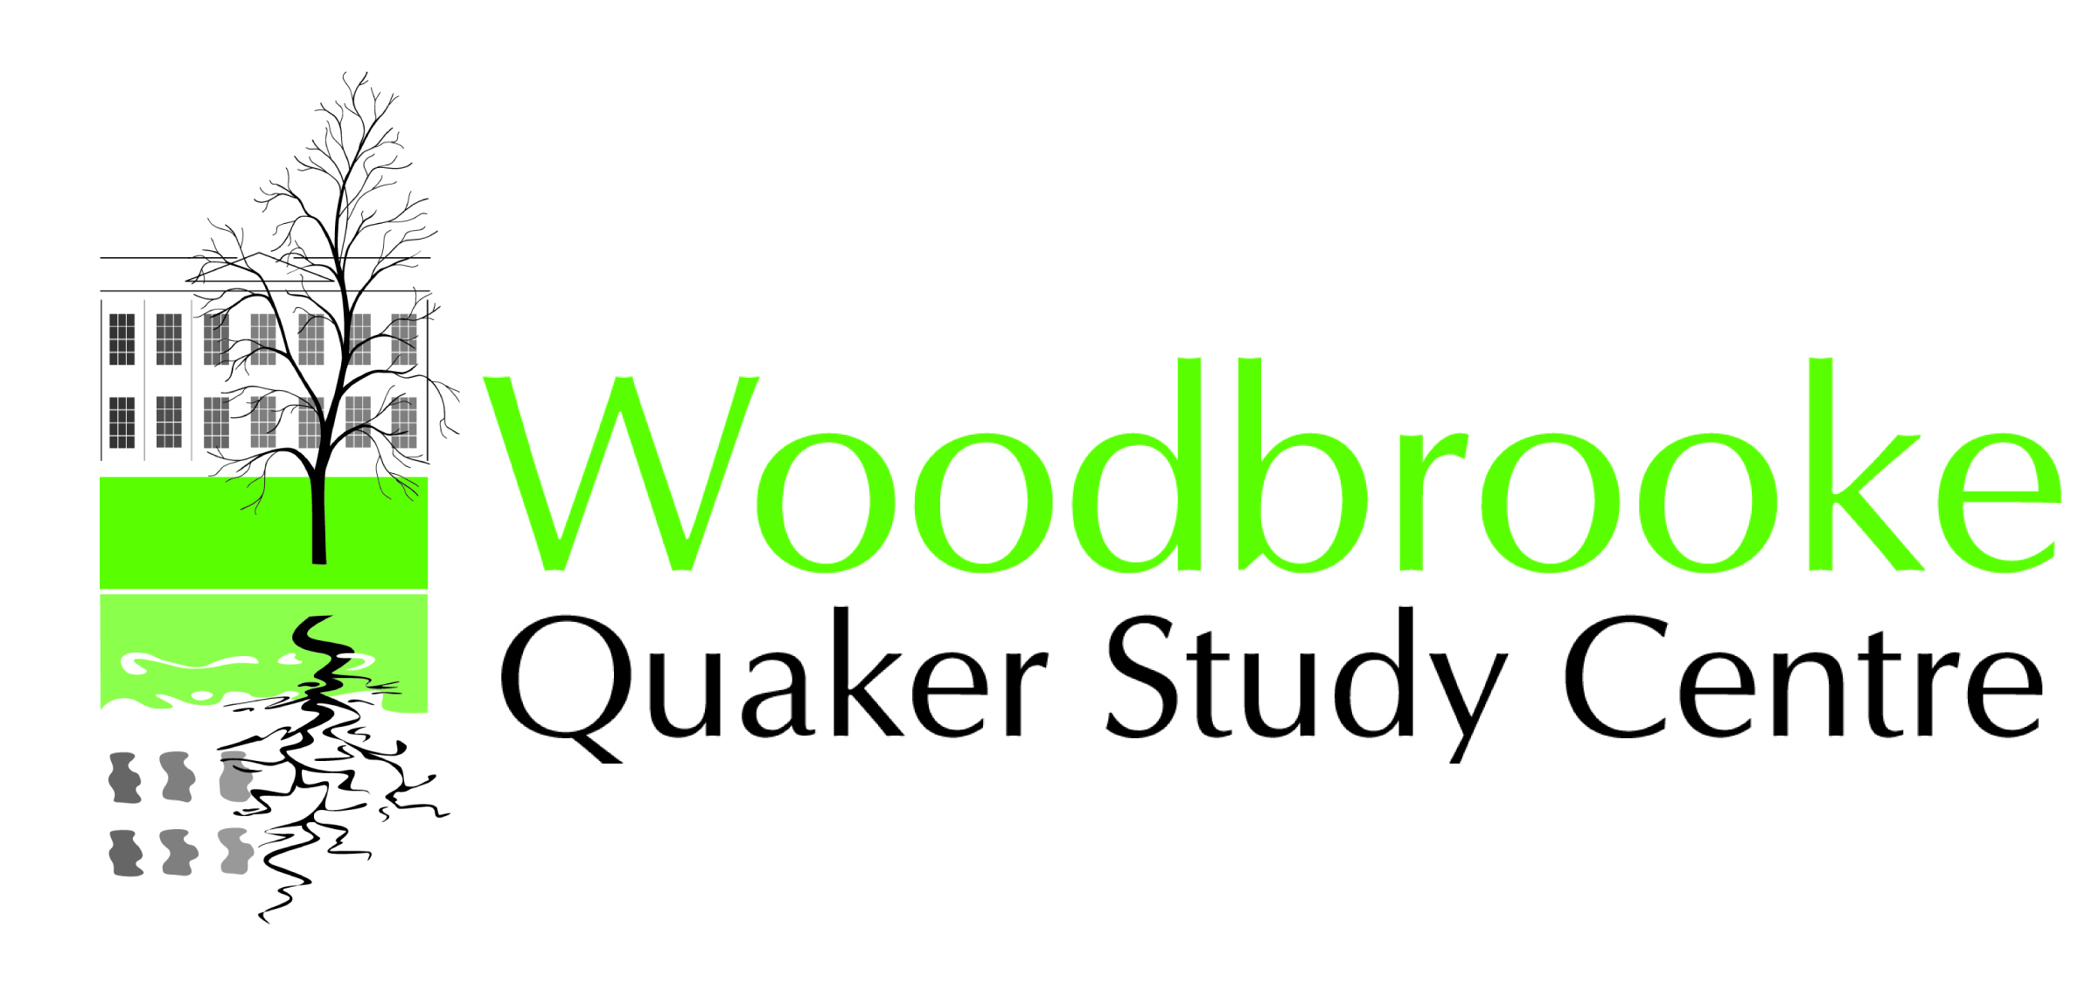

The Gerald Hodgett Award Scheme.

Market Research

The Higher Education Awards Group and the Centre for Postgraduate Quaker Studies at Woodbrooke are very pleased to announce the Gerald Hodgett Award Scheme offering grants of up to £1000 per applicant for the dissemination of research findings for the benefit of Britain Yearly Meeting (BYM), its Meetings and members by students and graduates of Quaker Studies and related post-graduate research.

- Grants will be up to £1000 per individual applicant with a total of £5000 being available for distribution in any one year.

- There is a total of £25,000 available for distribution over not less than 5 years.

We encourage a creative approach from applicants, for them to think widely about how research may best be disseminated and how a Hodgett Award might help.

We ask applicants to meet with a group of Quakers from outside their own Meeting to outline the project and to share their view of the benefit it will bring to the Yearly Meeting. This form need to be given to those Friends by the applicant. The information should remain confidential to the applicant, the Friends he/she meets with and the Gerald Hodgett Award Group..

Please help the discernment of the Award Group by answering these questions. Feel free to add additional sheets if necessary. An electronic copy of the form can be supplied.

Name of applicant:

- How clearly defined did you feel the proposal to be?

- Could you identify clear outcomes?

- Do you feel these will be of benefit to the life of the Yearly Meeting and if so, in what way? What is the need in your opinion for this work?

- Would you be willing to support the applicant further as the project develops, if the applicant felt this would be helpful?

Please send your response to Betty Hagglund, CPQS, Woodbrooke, 1046 Bristol Road, Birmingham B29 6LJ by October 30.
betty.hagglund@woodbrooke.org.uk 0121 415 6761

